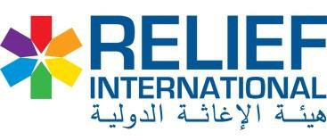

Annex – A (AICS Waste management supplies)

# | Item Description | Unit | QTY | Unit Cost SDG | Total cost SDG
1 | Heavy Gloves | Pair | 14
2 | Mask (50 peace per carton) new date | Carton | 20
3 | Lab Coat green color with AIC & RI logo | Packs | 8
4 | Safety Boots (size 42-45) | Pair | 8
5 | Apron with AIC & RI logo | Pcs | 14
Total cost : |  | SDG

Annex – B (AICS WASH supply items for HFs and IDP location including cleaning tools)

# | Item Description | Unit | QTY | Unit Cost SDG | Total cost SDG
1 | Solid sops 180g (40 pes per carton) | Carton | 20
2 | Liquid soaps (500 ml) | Pcs | 70
3 | Dettol’s 500 ml | Pcs | 70
4 | Brooms | Pcs | 14
5 | Towel (Biskeer) | Pcs | 14
6 | Bucket 12 litters with AIC and RI logo | Pcs | 14
7 | Waste collector | Pcs | 14
8 | Waste collector (Sac) | Pcs | 100
9 | Wheel prow with AIc and RI logo | Pcs | 14
11 | Gown with RI and AIC logo | Pcs | 50
12 | Scuttle local made | PCs | 70
13 | Axe with iron handle | Pcs | 7
14 | Sweeper with iron Handle | Pcs | 21
15 | Shovel with iron handle | Pcs | 21
16 | Hand washing facilities with AIC and RI logo, the BOQ attached spreately | Pcs | 14
Total cost : |  | SDG

